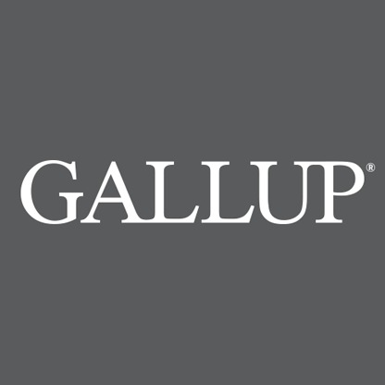

Americans’ Economic Confidence High in

2017

BY ANDREW DUGAN / January 2, 2018, 7:37 AM

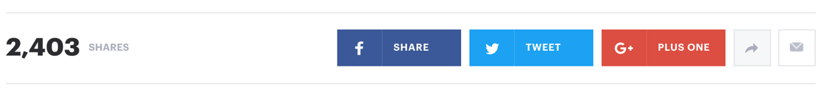

Americans’ views of the U.S. economy were positive on balance in 2017, with Gallup’s U.S. Economic Confidence Index averaging +6 for the year. This was a 16-point increase from 2016 and is the index’s first positive annual average since Gallup began daily tracking of this measure in 2008.

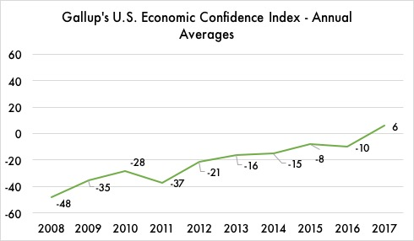

Gallup's U.S. Economic Confidence Index is the average of two components: how Americans rate current economic conditions and whether they feel the economy is improving or getting worse. The index has a theoretical maximum of +100 if all Americans were to say the economy is doing well and improving, and a theoretical minimum of -100 if all were to say the economy is doing poorly and getting worse.

Americans’ economic confidence was positive in 2017 for the first time in years. Source: Gallup Tracking Polls, 2008 – 2017.

Overall, Americans' confidence in the economy has gradually improved since the recession year of 2008, when economic confidence averaged -48.

Confidence strengthened over the next four years, with the index's annual average increasing by a total of six points between 2013 and 2016.

The election of Donald Trump in late 2016 helped push the index into positive territory on a consistent basis, as confidence improved after his election. The index's monthly average hit a then-record high of +9 in December 2016.

This newfound confidence carried over into 2017. The index averaged +10 or higher in eight separate weeks, including a score of +13 for the final week of the year.

Bucking Trend, Republicans Were Less Biased About the Economy in 2016

The way Republicans view the economy underwent a dramatic shift in 2016.

Gallup’s Economic Confidence Index, based on an average of how Americans view economic conditions over the past year, showed that Republicans displayed far less bias in their responses compared to previous years.

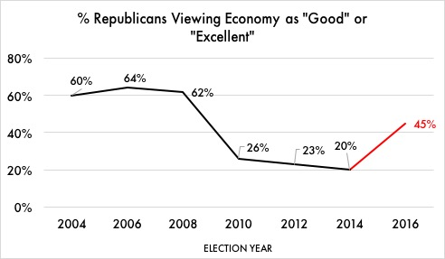“While Republicans were generally optimistic about the economy under George W. Bush, they took a more dismal view during Barack Obama’s two terms,” said the release from Gallup. “In 2016, however, Republicans changed their views to align more closely with objective economic conditions.”

In 2004, about 60% of Republicans said the economy was “good” or “excellent.” When surveyed in 2008 – a few months prior to the onset of the recession – 62% of Republicans said the same.

Republicans were far less biased in their evaluations in 2016 compared to past years. Source: Gallup Tracking Polls, 2004 – 2016.

Following Obama’s election, however, Republicans became far more pessimistic in their evaluations. By 2012, only 23% viewed the economy as “good” or “excellent,” despite stock market gains and decreasing unemployment between 2008 and 2012.

In 2016, however, Republicans bucked the trend, with about 45% viewing the economy positively.

## “This is truly a remarkable change in Republicans’ thinking about the economy,” said Gallup’s Senior Research Director Matt Bevins. “For the past 8 years, they have been extremely pessimistic, despite objective indicators showing the economy is in good health. In 2016, Republicans’ views hewed more closely to reality — even before the election of Donald Trump.”

Bucking trends, Democrats were less biased about the economy in 2016 

The way Democrats view the economy underwent a dramatic shift in 2016.

Gallup’s Economic Confidence Index, based on an average of how Americans view economic conditions over the past year, showed that Democrats displayed far less bias in their responses compared to previous years.

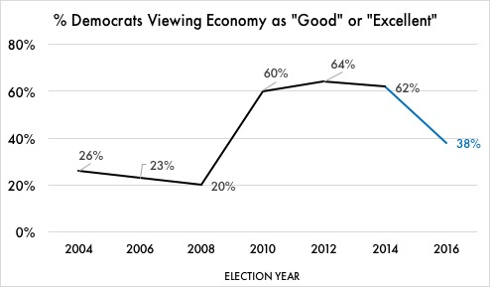“While Democrats were generally pessimistic about the economy under George W. Bush, they took a more positive view during Barack Obama’s two terms,” said the release from Gallup. “In 2016, however, Democrats changed their views to align more closely with objective economic conditions.”

In 2004, only about 26% of Democrats said the economy was “good” or “excellent.” When surveyed in 2008 – a few months prior to the onset of the recession – only 20% of Democrats said the same.

Democrats were far less biased in their evaluations in 2016 compared to past years. Source: Gallup Tracking Polls, 2004 – 2016.

Following Obama’s election, however, Democrats became far more optimistic in their evaluations. By 2012, 64% viewed the economy as “good” or “excellent,” despite a mostly stagnant stock market and few reductions in unemployment between 2008 and 2012.

In 2016, however, Democrats bucked the trend, with only about 38% viewing the economy positively.

“This is truly a remarkable change in Democrats’ thinking about the economy,” said Gallup’s Senior Research Director Matt Bevins. “For the past 8 years, they have been extremely optimistic, outpacing objective indicators showing only modest economic growth. In 2016, Democrats’ views hewed more closely to reality — even before the election of Donald Trump.”

Continuing trends, Republicans remained biased about the economy in 2016

Despite sustained economic growth, Republicans continued to be pessimistic about the state of the economy in 2016.

Gallup’s Economic Confidence Index, based on an average of how Americans view economic conditions over the past year, showed that Republicans’ views about the economy changed little from in their responses in previous years.

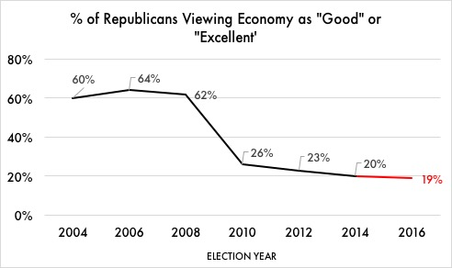“While Republicans were generally optimistic about the economy under George W. Bush, they took a more dismal view during Barack Obama’s two terms,” said the release from Gallup. “In 2016, they continued this downward trajectory, even as objective economic conditions improved.”

In 2004, about 60% of Republicans said the economy was “good” or “excellent.” When surveyed in 2008 – a few months prior to the onset of the recession – 62% of Republicans said the same.

Republicans continued to hold skewed economic views in 2016. Source: Gallup Tracking Polls, 2004 – 2016.

Following Obama’s election, however, Republicans became far less optimistic in their evaluations. By 2012, only 23% viewed the economy as “good” or “excellent,” despite stock market gains and decreasing unemployment between 2008 and 2012.

In 2016, only 19% of Republicans viewed the economy positively.

“This is pretty much in line with in Republicans’ thinking about the economy over the past 8 years,” said Gallup’s Senior Research Director Matt Bevins. “During the Obama presidency, they were extremely pessimistic, despite evidence showing the economy is in good health. In 2016, they continued the trend.”

Continuing trends, Democrats remained biased about the economy in 2016

Despite modest economic growth, Democrats continued to be optimistic about the state of the economy in 2016.

Gallup’s Economic Confidence Index, based on an average of how Americans view economic conditions over the past year, showed that Democrats’ views about the economy changed little from in their responses in previous years.

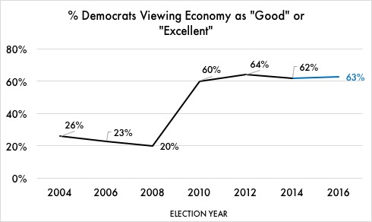

“While Democrats were generally pessimistic about the economy under George W. Bush, they took a more positive view during Barack Obama’s two terms,” said the release from Gallup. “In 2016, they continued this upward trajectory, even as objective economic conditions stayed mostly the same.”

In 2004, only about 26% of Democrats said the economy was “good” or “excellent.” That number decreased slightly in 2006 to 23%. When surveyed in 2008 – a few months prior to the onset of the recession – 20% of Democrats said the same.

Democrats continued to hold skewed economic views in 2016. Source: Gallup Tracking Polls, 2004 – 2016.

Following Obama’s election, however, Democrats became far more optimistic in their evaluations. By 2012, 64% viewed the economy as “good” or “excellent.” That number shrank slightly to 62% in 2014, despite a mostly stagnant stock market and few changes in unemployment between 2008 and 2012.

In 2016, 63% of Democrats viewed the economy positively.

“This is pretty much in line with in Democrats’ thinking about the economy over the past 8 years,” said Gallup’s Senior Research Director Matt Bevins. “During the Obama presidency, they were extremely optimistic, despite evidence showing the economy was only in fair health. In 2016, they continued the trend.”